HR Analytics Predicting Employee Promotions

IST 707 APPLIED MACHINE LEARNING

Table of Contents

Introduction 2

Analysis 2

The Data 2

Exploratory Data Analysis 7

Model Analysis 18

Association Rule Mining 18

Decision Tree 21

Naïve Bayes 23

Support Vector Machines 24

Random Forest 27

Results 28

Conclusions 29

Appendix A (R code): 29

Appendix B (Python code): 29

# Introduction

“Moving up the ladder” is used to describe the way one navigates a company. In terms of a career, a promotion refers to the advancement of an employee's rank or position in a hierarchical structure. In marketing, promotion refers to a different sort of advancement. A sales promotion entails the features—via advertising and/or a discounted price—of a particular product or service. A job promotion is usually handed to an employee who has displayed exceptional performance or has developed the appropriate skills and knowledge necessary to take on additional job responsibility. In the latter case, the employee may need to work for a company for a required amount of time to be eligible for a promotion. A promotion will typically deliver a higher salary to compensate for the increased job responsibilities. A promotion might also include expanded benefits and managerial authority over other employees.

In human resources management, it is important to have a robust promotion policy communicated explicitly to the employees. Through the job promotion policy, criteria for recommending and approving positions in the organization are governed. Just several years ago, the standard formula to calculate promotions centered around their tenure with the company. With so many different components currently driving promotion decisions, it is difficult to understand why an individual gets the promotion. Some people have been passed over for a key promotion despite stellar results and glowing reviews. Responses to improve the situation are usually vague and unsatisfying, leaving employees angry, frustrated, and unsure of their status with the company. Promotion decisions seem arbitrary and political. What is really going on?

Does an employee have to earn a certain educational standard to get promoted? Does an individual need to be in sales or technology to get promoted faster? Does age play a factor in a promotion? What really separates an individual to receive the promotion? Identifying important factors in human resources may help the department determine a focus for getting an exceptional employee promoted. In the review of eligible candidates getting promoted, what characteristics bring more success to others? Is it possible to pre-determine employees who will be promoted?

# Analysis

## The Data

A large MNC has 9 broad verticals across the organization. One of the problems is identifying the right people for promotion (only for manager positions and below) and prepare them in time to be ready for the role. The final promotions are only announced after the evaluation, and this leads to delay in transition to new roles. Hence, the company needs help in identifying the eligible candidates at a particular checkpoint so that they can expedite the entire promotion cycle. The corporation has 9 broad verticals and wants to identify the best employees for promotion. Then, they can prepare these employees for their new role ahead of time. In the dataset are the employee ID, department, region of the individual, educational background, gender, how the employee was recruited, training sessions, age, ratings for previous year, service in the company, awards, and average training score of the employee.

The dataset was provided on Kaggle’s website (https://www.kaggle.com/arashnic/hr-ana). The dataset provided 13 columns with 54,808 rows. Each row contains a single employee’s information. The dataset consists of categorical, binary, nominal, ordinal, and continuous data. The preprocessing of our data was completed by reading it into RStudio and Juptyer Notebooks using R and Python respectively. The first step in our data preprocessing is to read in our CSV file provided by the Kaggle project link. Please see the attached table, which describes our dataset in detail.

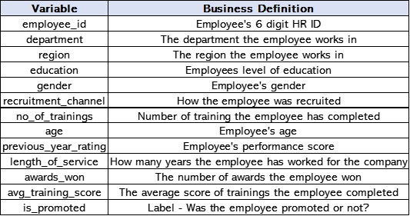

The pre-processing and cleaning of the data consisted of:

1. Deleting missing values using na.omit() for the whole dataset
   1. Out of the 13 variables in our dataset, 5 were chr variables, and the rest were initially of data type int. Out of those int variables, most were discrete variables, so replacing missing values with the mean of that column would not have made logical sense. Therefore, the method used for dealing with missing values was to delete them altogether.
2. Converting is_promoted values from 0,1 to “Not Promoted” and “Promoted”, respectively
3. Converting awards_won. values from 0,1 to “No Awards Won In Previous Year” and “Awards Won In Previous Year”, respectively
4. Converting the following variables from chr to factors: department, region, education, gender, recruitment_channel, and is_promoted.
5. Removing the employee_id column from the dataframe
6. Discretizing the variables age, avg_training_score and length_of_service into custom bins before performing ARM

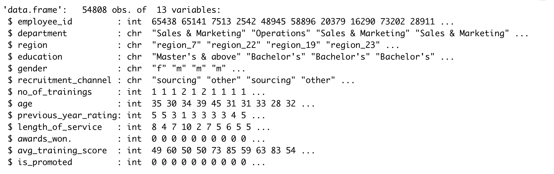

Cleaning missing values:

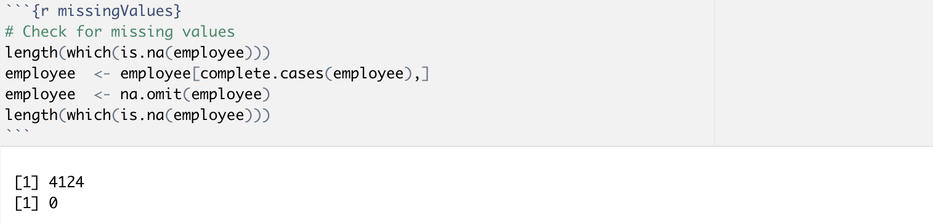

Converting chr variables to factors:

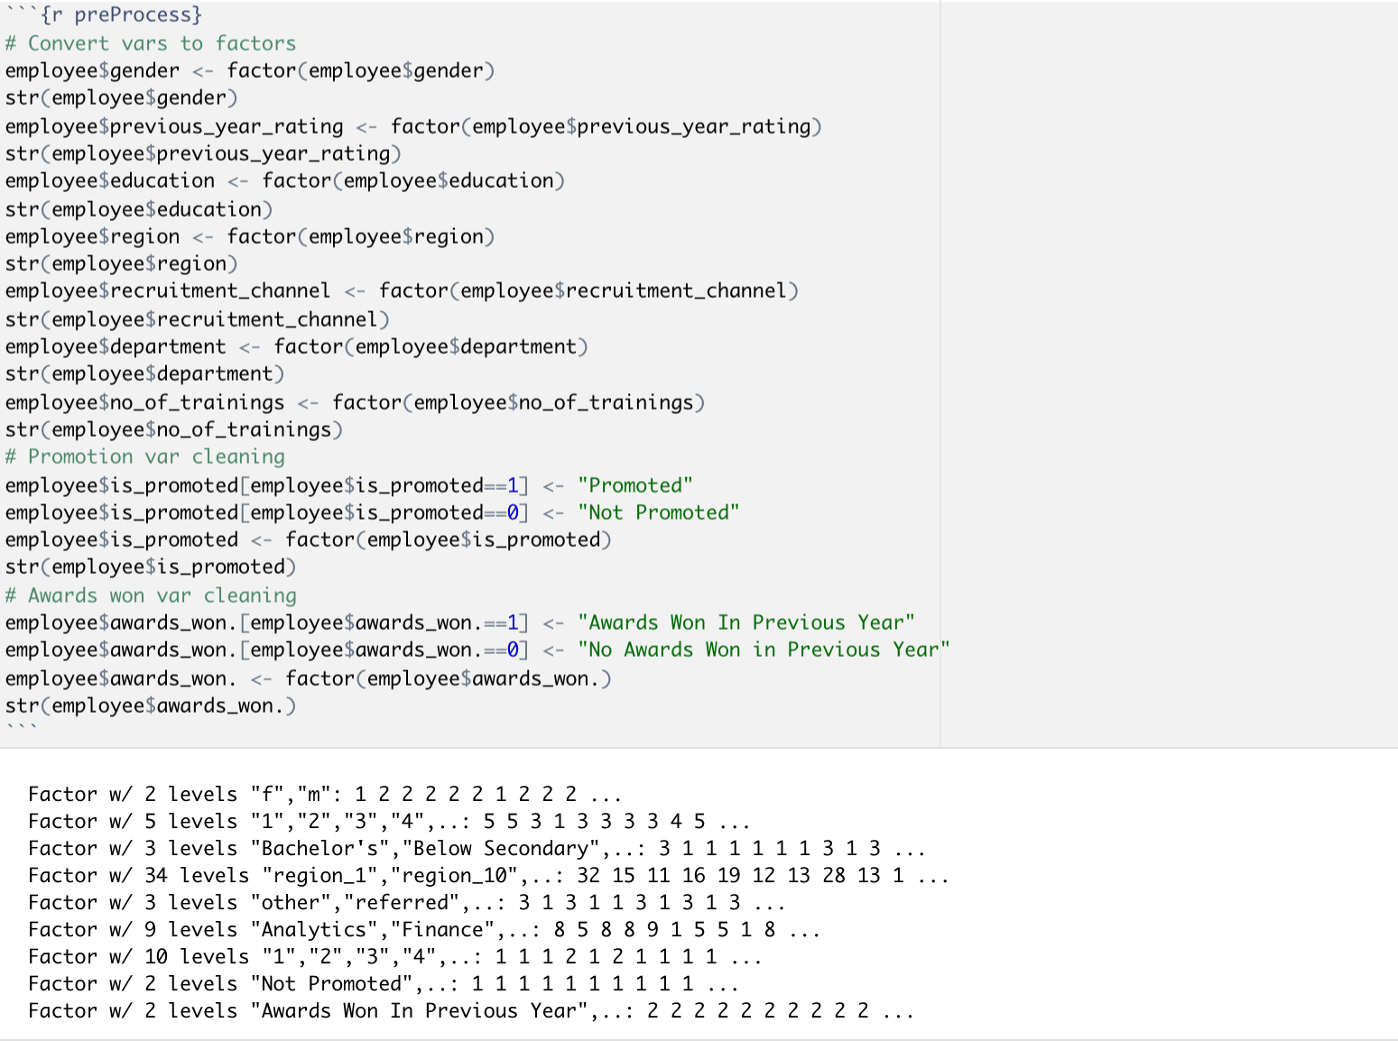

Removing employee_id column:

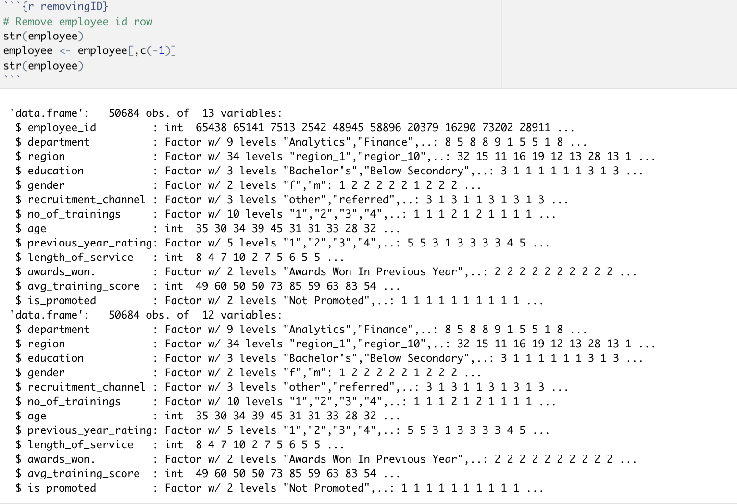

Variable length_of_service discretization:

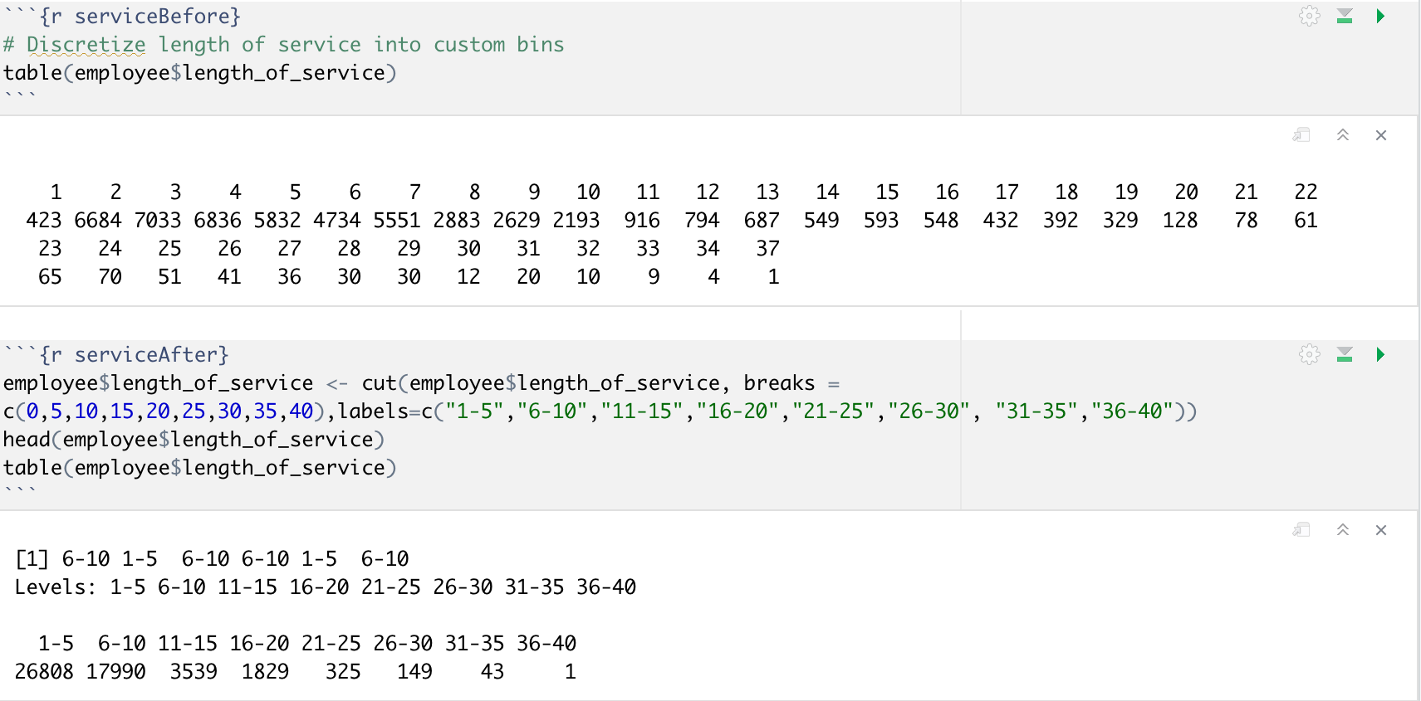

Variable avg_training_score discretization:

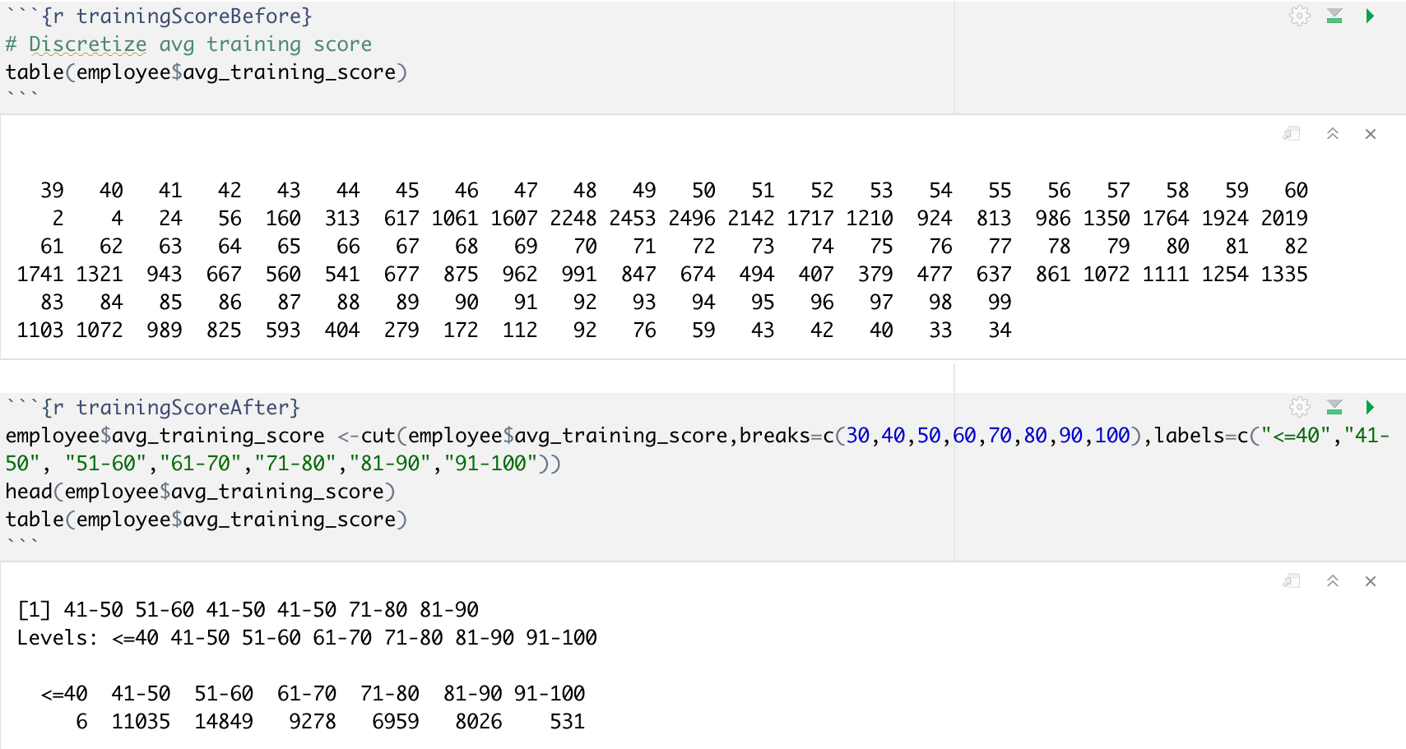

Variable age discretization:

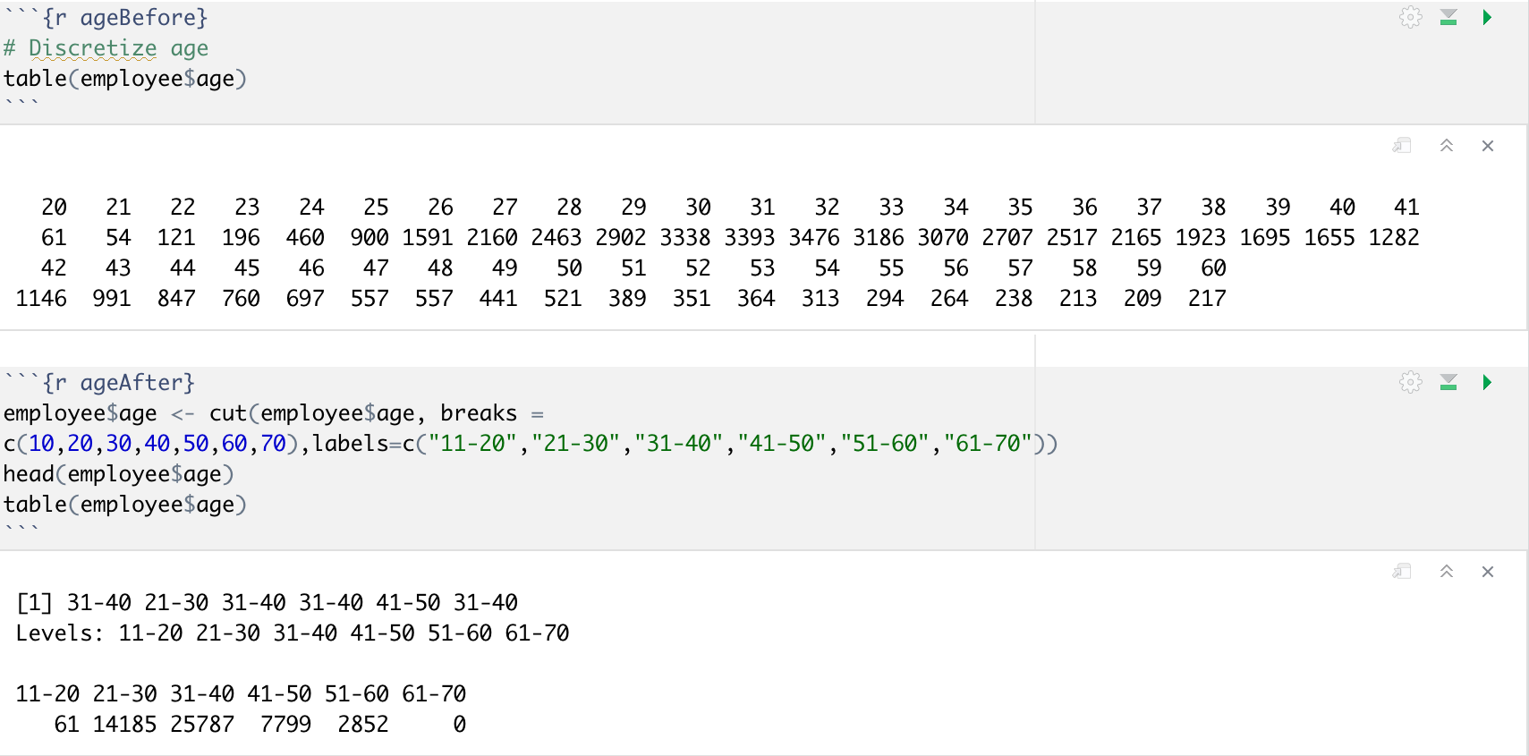

## Exploratory Data Analysis

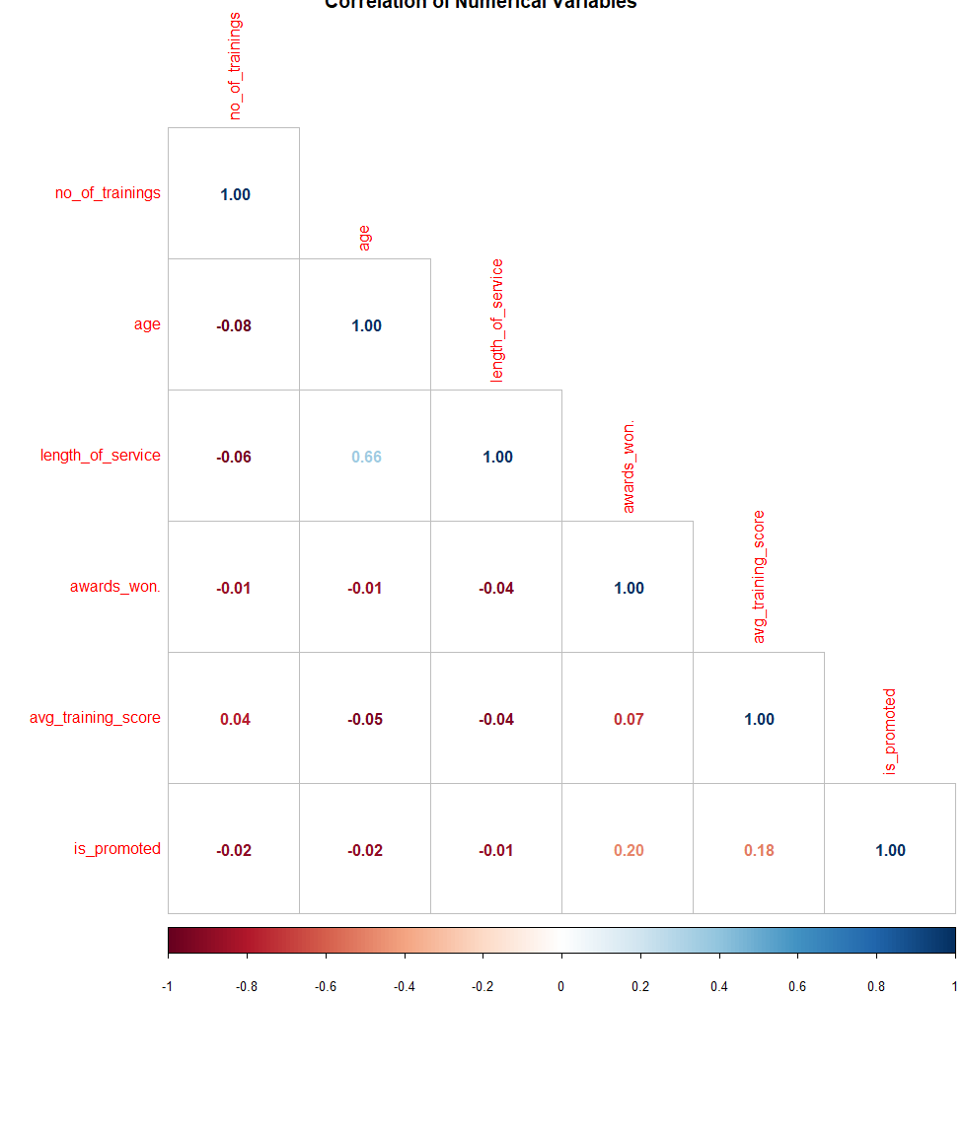

The correlation matrix above shows that the variables with the highest correlation are age and length of service. Awards won and being promoted have a positive correlation of 0.20. Average training scores and being promoted also have a positive correlation of 0.18.

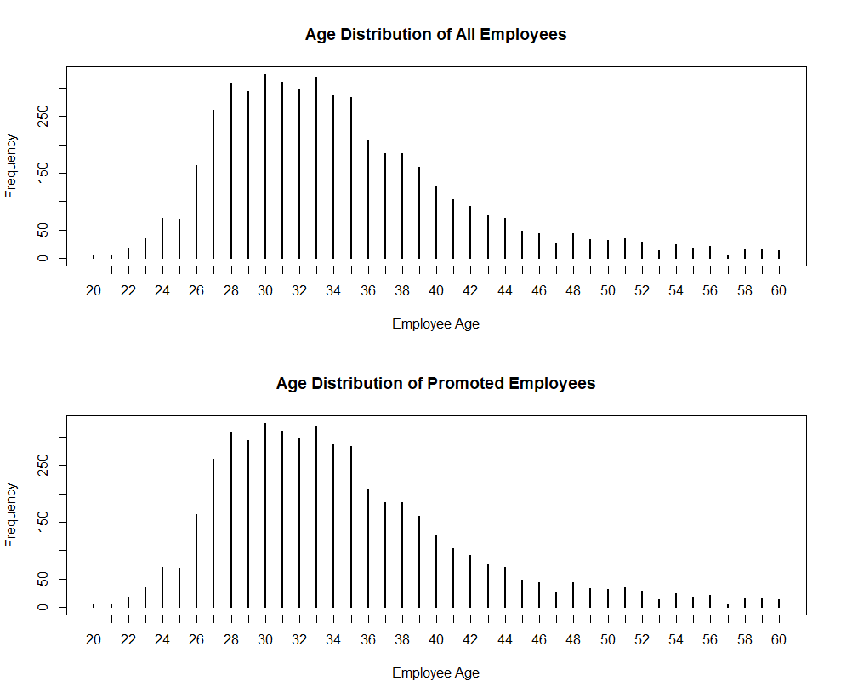



The age histograms above show that most employees fall between the ages of 26 years and 45 years, and the average age is 35 years. The distribution is skewed right because the mean is greater than the median.



The initial look at the age histogram by gender shows that there are far fewer females than males in the company. Both distributions are skewed right.

The gender pie chart supports the above observation that there are far fewer females than males in the company.

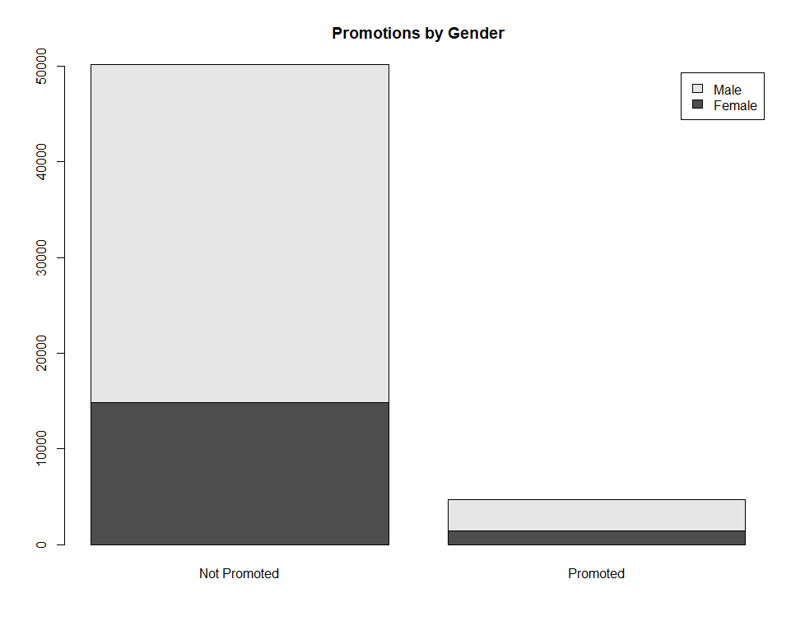

The initial look at the promotion by gender barplot above shows that out of the employees that were promoted, male employees were promoted much more than female employees.



The colored barplot above however, shows that 9.07% of females were promoted as opposed to only 8.31% of males.



The promotion and scores boxplot above shows that employees who were promoted had higher average training scores than employees who were not promoted.

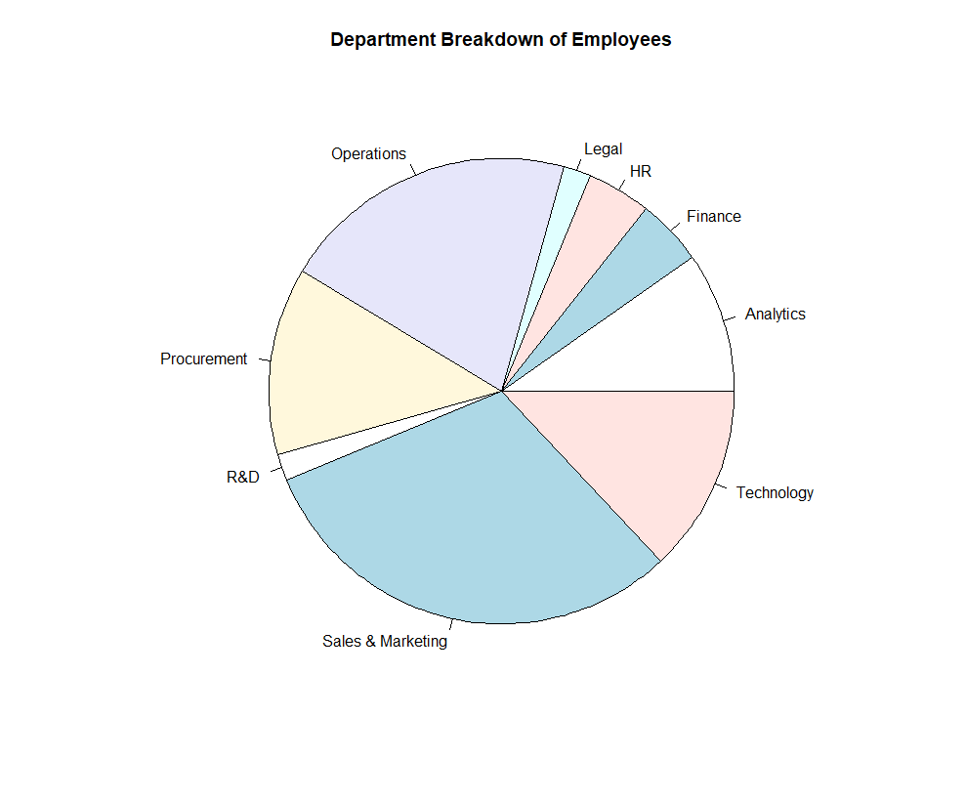

The pie chart of the department breakdown shows that Sales & Marketing, Operations, and Procurement had the highest numbers of employees.



The promotion by department barplots above show that the departments with the highest number of employee promotions are Technology, Procurement, and Analytics.



The colored barplots above show promotions by region and department. Regions 2, 22, and 7 have the highest number of employees. Therefore, it makes logical sense they would also have the highest number of promotions.



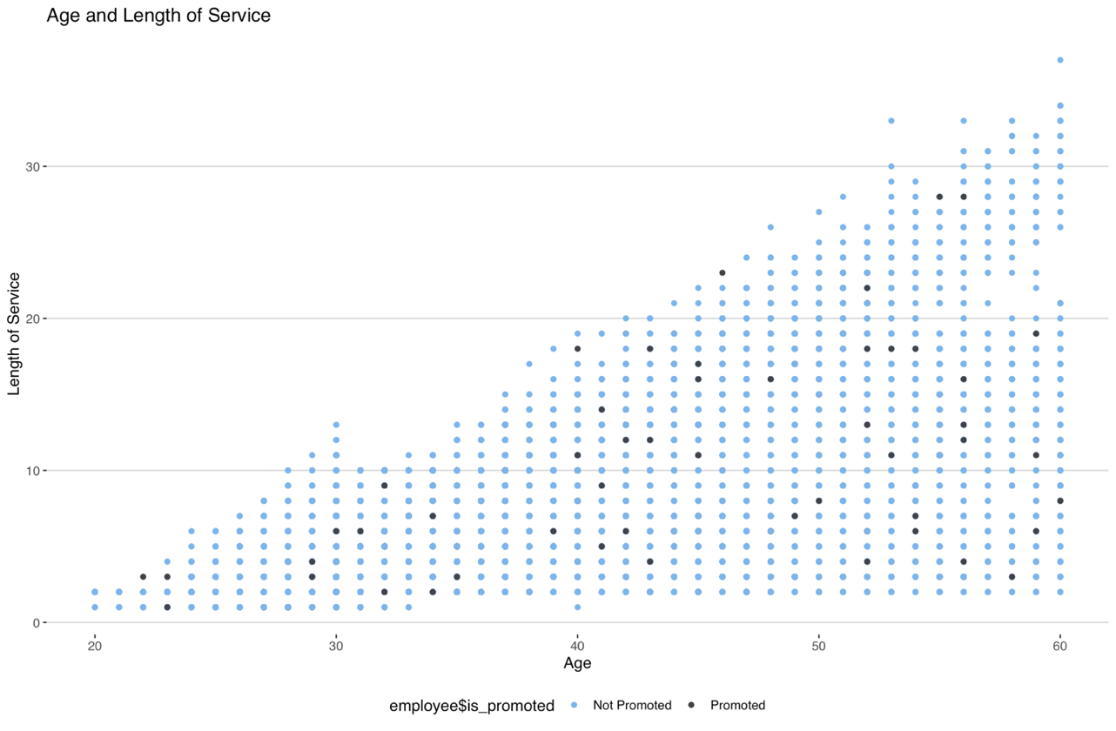The regions and scores boxplots show that, in all the regions, the employees who were promoted had higher average training scores than employees who were not promoted. Region 17 has 2 outliers, which indicates that 2 employees in that region were promoted even though their training scores were low.

The above scatterplot shows that as the age of the employee increases, so does the length of service. An interesting observation is that some employees who were 30 years old have been with the company for over 10 years. Since there is not enough information about whether they joined as full-time employees or interns, no definitive conclusion can be made.



The education percentages pie chart shows that most employees (65.9%) had a bachelor’s degree, and there were ~5% of employees whose education level was below secondary.



The above barplot shows that employees with a master’s degree and above had the highest chance of being promoted. As the level of education decreased, the chance of being promoted (percentage) also decreased.



The recruitment channel pie chart shows that most employees were either recruited through a channel not specified or through a sourcing channel. Examples of recruitment sourcing channels are LinkedIn, Glassdoor, Google, etc. The type of recruitment sourcing channels was not specified for this dataset.

Although the percentage of employees who had referrals was only 2%, those employees had the highest promotion percentage. Employees who used recruitment sourcing channels had the second highest promotion percentage, while employees who used other recruitment channels had the lowest promotion percentage.



The barplot above shows promotion by awards won. Employees who won awards in the previous year had a 36% higher chance of being promoted than employees who did not win an award in the previous year.

The age and number of trainings by department graphs above show that Sales & Marketing, Procurement, and Technology conducted the highest number of trainings for employees of all age ranges. Sales & Marketing and Procurement conducted 10 trainings for employees above the age of 50, yet those employees were not promoted.



The promotion by previous year rating barplots above show that employees who had a previous year rating of 5 had the highest promotion percentages. Employees with ratings of 3 had slightly higher promotion percentages than employees with ratings of 4. This could be due to other factors such as their average training score, awards won in the previous year, and level of education.

## Model Analysis

### Association Rule Mining

[Association analysis](https://www-users.cs.umn.edu/~kumar001/dmbook/ch6.pdf) is a useful method for finding relationships between variables in large datasets. The relationships found can be shown in the form of association rules, which are sets of frequent items that occur. The strength of an association rule can be measured in terms of its confidence and support values. Support determines how frequently a rule is applicable to the dataset, while confidence determines how frequently items in *Y* appear in transactions (or rules) that contain *X*.

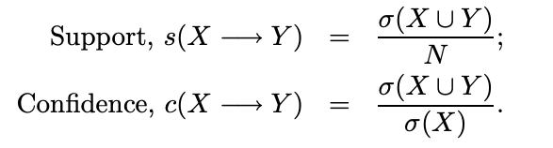

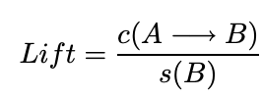In some cases, rules with high confidence measures ignore the support of the itemset of the rule. A way to address this problem is by applying lift. Lift is a metric that computes the ratio between an association rule’s confidence and its support of the itemset in the rule.

The Apriori Algorithm is the first association rule mining algorithm where support-based pruning was used to systematically control the exponential growth of the itemsets.

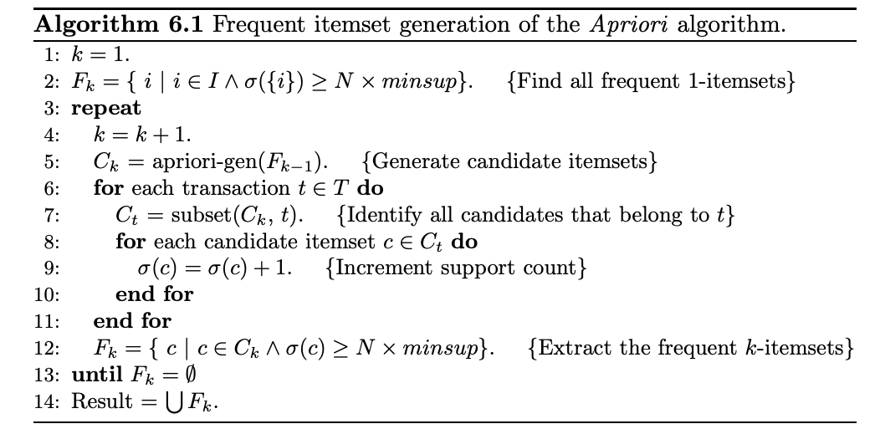

Top 10 Rules for Highest Lift

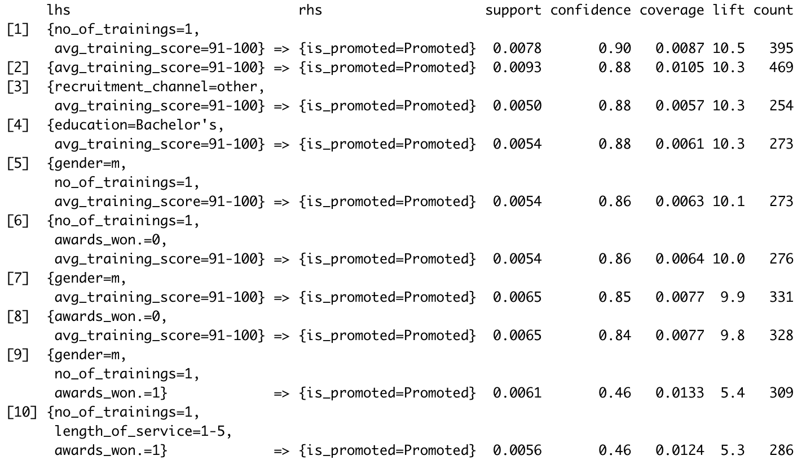

The top 10 rules above are the rules generated in R for the highest lift values. An explanation of the first rule, for example, indicates that with 1 training and an average training score between 91-100, it can be said with 90% confidence that an employee will be promoted.



The scatterplot above shows the highest lift values for the top 8 rules in dark red at the top of the graph. The rest of the lighter points fall towards the bottom of the graph where the confidence and support values are lower.

Top 10 Rules for Highest Support

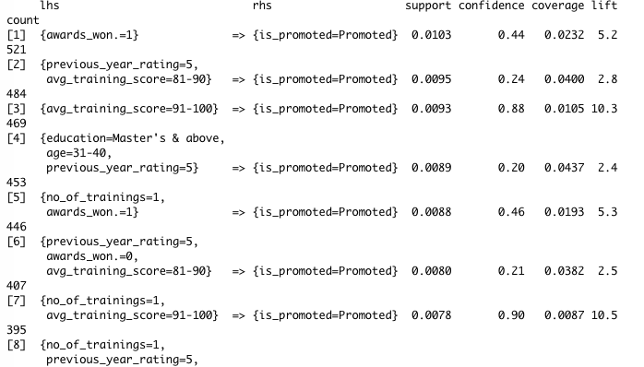

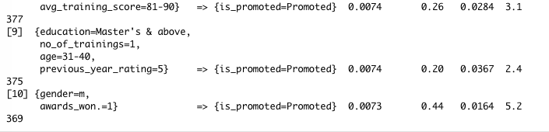

The top 10 rules for highest support are shown above. Rule #1 has the highest support value of 0.0103 in the list of the 10 rules, although the confidence and lift values are not the highest in the ruleset.

Top 10 Rules for Highest Confidence

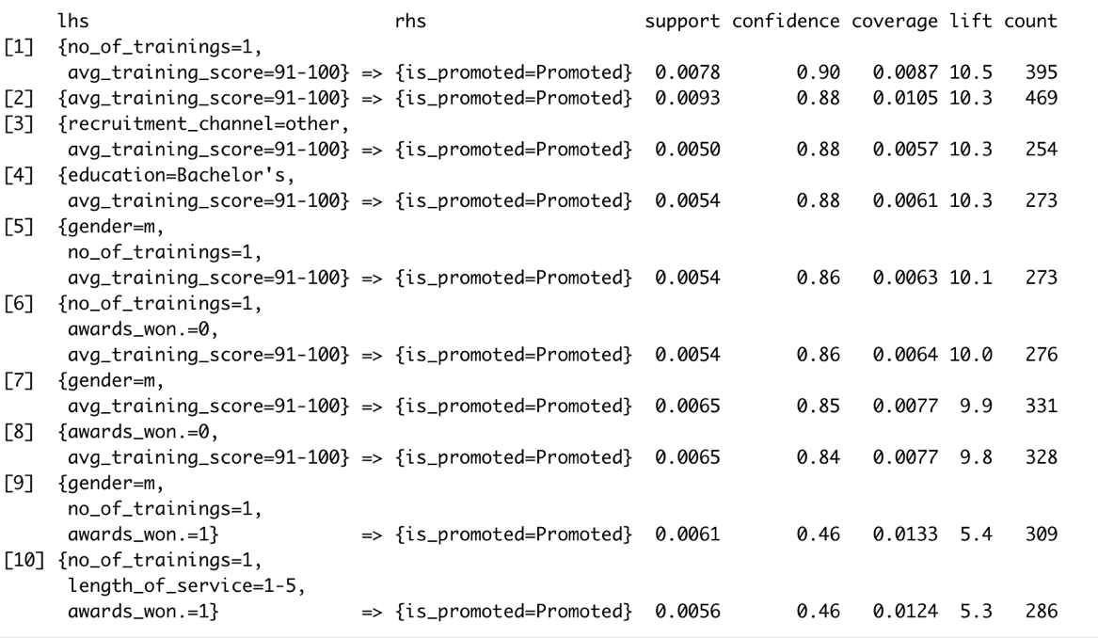

The top 10 rules for highest support are shown above. Rule #1 has the highest confidence. A confidence level of 90% is very high and means that with 1 training and a high average training score, the chance of the employee being promoted is very high.

### Decision Tree

A Decision Tree Model is a classification technique that predicts the class of a target variable based on multiple input variables. The input variables can be used for various decision points to classify the data. A collection of these decision points is known as a decision tree.

To model employee promotions, a decision tree algorithm was used to predict which employees would be promoted. The data was down-sampled so that the positive and negative class had equal frequency. A default decision tree model yielded 68.1% test accuracy. To further tune the model, a second decision tree pruned to allow only two decision points was used. This tree yielded 66.4% test accuracy. A third model with 20 cross-validations yielded 68.0% test accuracy.

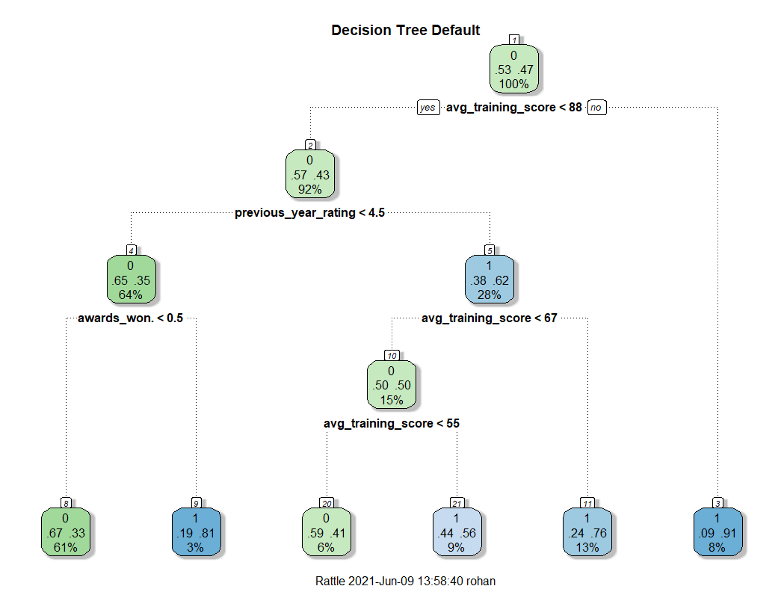

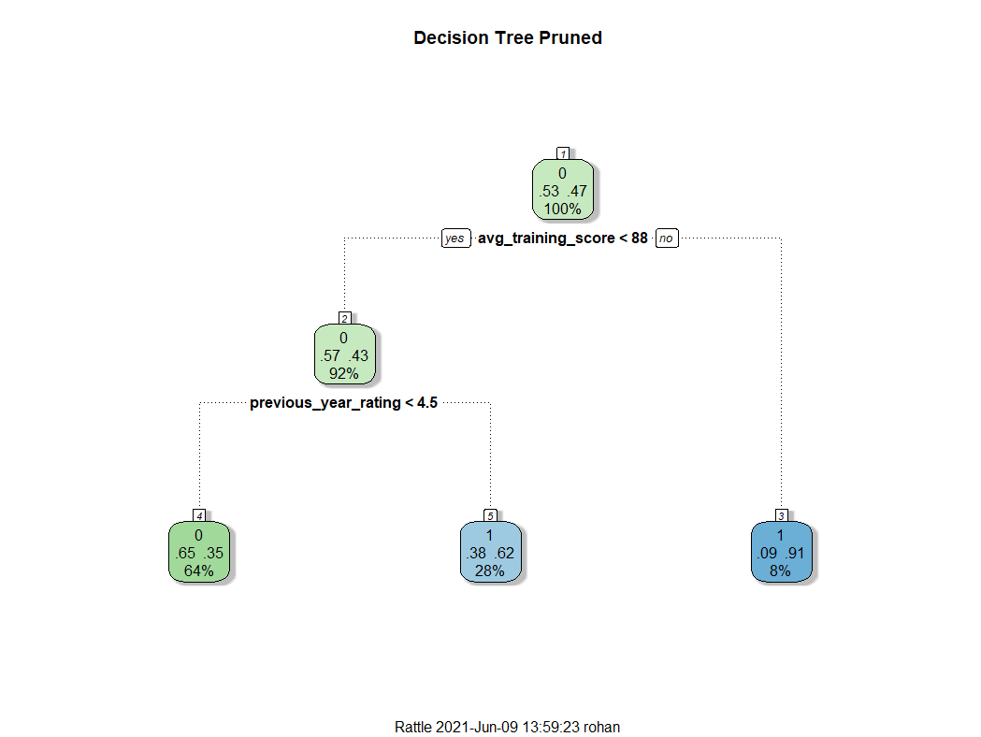

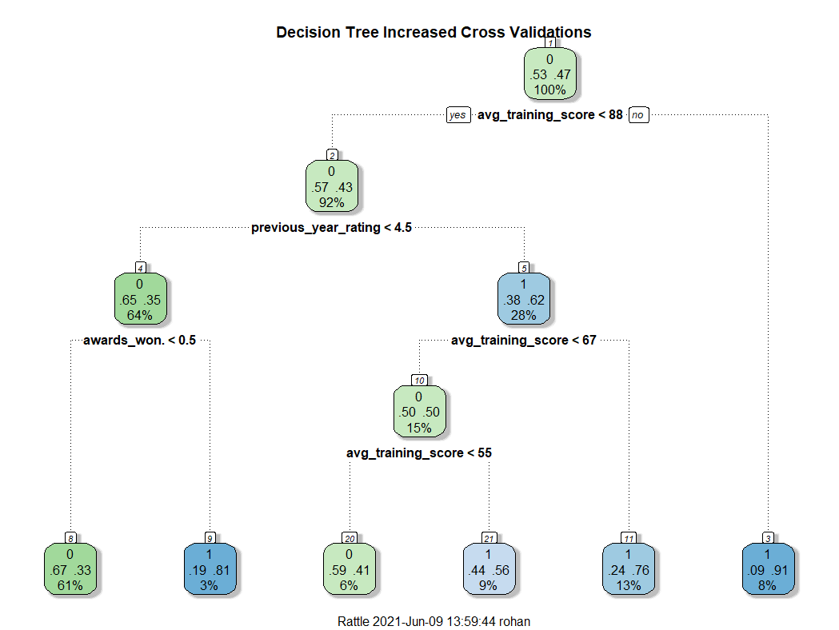

It was determined that the default parameters were ideal in for decision tree modeling of employee promotions as the pruned tree decrease accuracy and the increased cross-validation tree increase compute time without improving accuracy.

Confusion Matrix for Default Decision Tree:

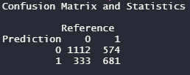

### Naïve Bayes

A Naïve Bayes model is used in classification problems and is based on Bayes Theorem which allows the probability that A will occur given that B has already occurred. The most important requirement of the Naïve Bayes model is that the various predictors should be independent.

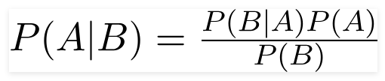

To model the employee data with Naïve Bayes, the data was preprocessed to convert all variables to factors. The data was also down-sampled so that the positive and negative class had equal frequencies. The Naïve Bayes classifier yielded 65% test accuracy.

Down-sampling technique:



Model Statistics:

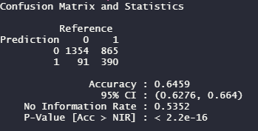

As shown below, the Naïve Bayes classifier performed better in predicting the negative class (not promoted) than the positive class (promoted).

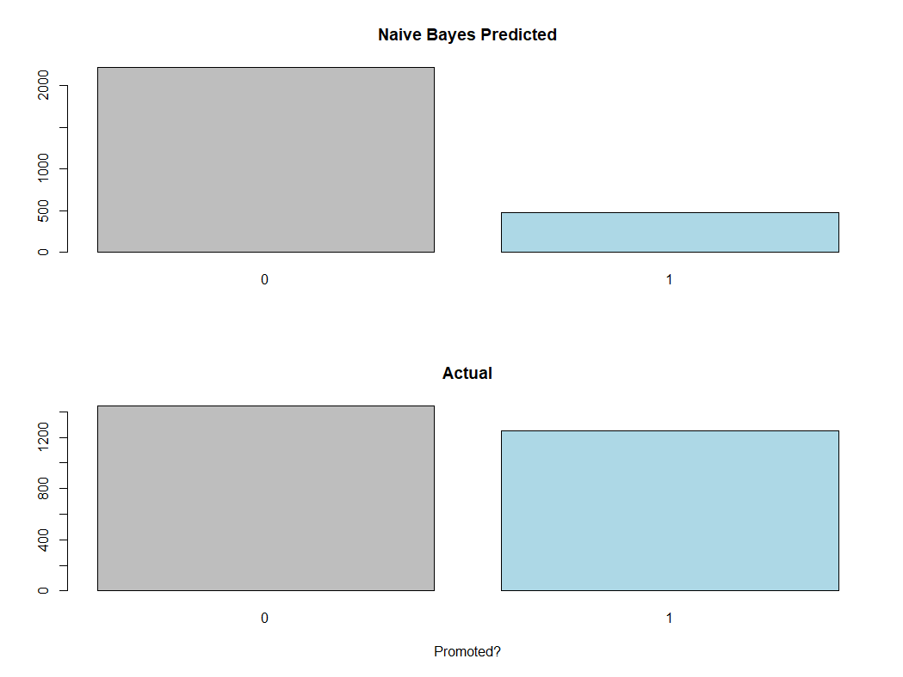

### Support Vector Machines

A Support Vector Machine is a supervised machine learning algorithm which can be used for both classification and regression problems. It follows a technique called the kernel trick to transform the data and, based on these transformations, it finds an optimal boundary between the possible outputs. To put it simply, it does extremely complex data transformations to determine how to separate the data based on the labels or outputs defined. The objective of the support vector machine algorithm is to find a hyperplane in an N-dimensional space (N — the number of features) that distinctly classifies the data points.

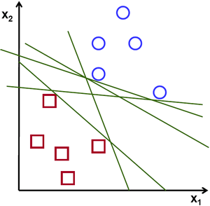 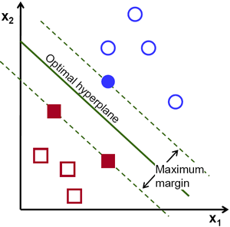

To separate the two classes of data points, there are many possible hyperplanes that could be chosen. Our objective is to find a plane that has the maximum margin (i.e. the maximum distance between data points of both classes). Maximizing the margin distance provides reinforcement so that future data points can be classified with more confidence.

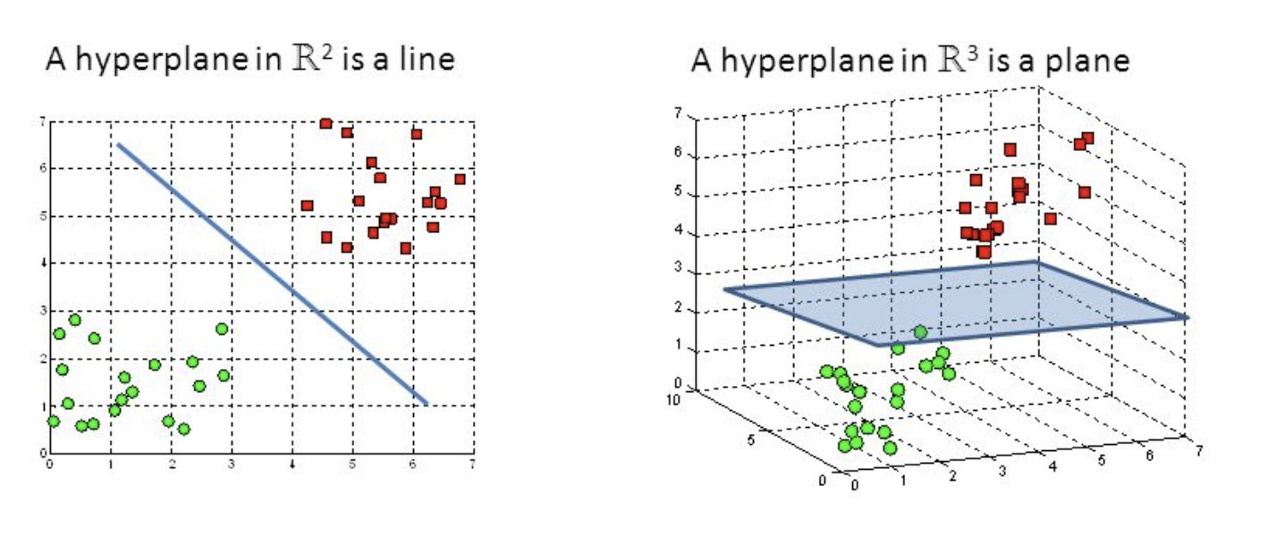

#### Hyperplanes in 2D and 3D feature space

Hyperplanes are decision boundaries helping to classify the data points. Data points falling on either side of the hyperplane can be attributed to different classes. Also, the dimension of the hyperplane depends upon the number of features. If the number of input features is 2, then the hyperplane is just a line. If the number of input features is 3, then the hyperplane becomes a two-dimensional plane. It becomes difficult to imagine when the number of features exceeds 3. Support vectors are data points that are closer to the hyperplane and influence the position and orientation of the hyperplane. Using these support vectors, we maximize the margin of the classifier. Deleting the support vectors will change the position of the hyperplane. These are the points helping us build our SVM.

In the dataset, the data has more non-promoted employees compared to promoted employees, so the model will need to either reduce the amount of non-promoted classification rows or add more promoted employees using synthetic data. In the Support Vector Machine model, it reduced the amount of non-promoted employees to accurately produce a solid model. The below view shows the NearMiss package being used. NearMiss is an under-sampling technique. Instead of resampling the minority class, this will make the majority class equal to minority class.

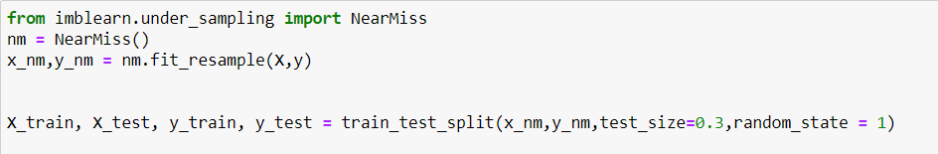

After the resampling technique, we can produce a poly kernel SVM model that will produce a more three-dimensional solution. In the below, one can see the accuracy at about 75%.

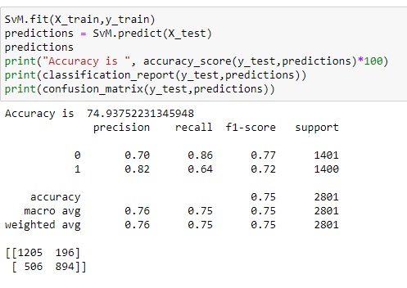

Next, the below shows a linear SVM model that has a slight increase in accuracy at about 75.90%. The SVM linear model does a better job of recognizing the promoted individuals and producing less type 1 errors.

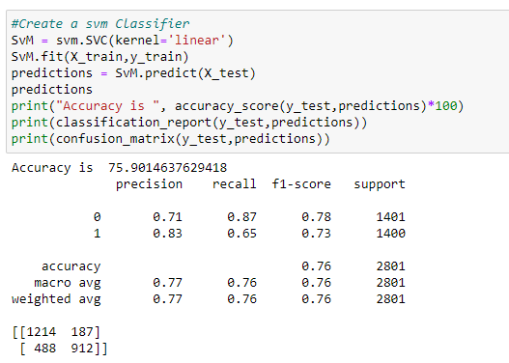

Lastly, the final Support Vector Machine model was Radial Basis Function which is a kernel whose value depends on the distance from line origin. The model produced an accuracy of 74.40% and decrease type 2 errors but increase in type 1 errors. Type 1 errors are known as false positives and occurs when the model incorrectly believes an employee to be promoted class instead of a non promoted class.

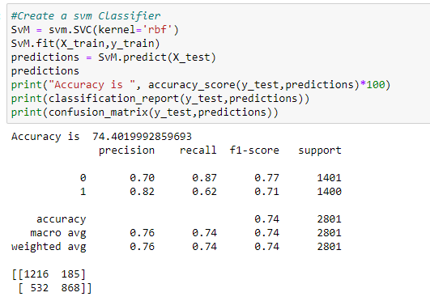

### 

### Random Forest

According to the scikit official documentation: “A random forest is a meta estimator that fits a number of decision tree classifiers on various sub-samples of the dataset and uses averaging to improve the predictive accuracy and control over-fitting. The sub-sample size is always the same as the original input sample size, but the samples are drawn with replacement.”

Random Forest algorithms create many individual trees from randomly selected subsets of the dataset. Each of these individual trees generates a classification/regression of objects within the subset of data. For each tree, the prediction error on the out-of-bag portion of the data is recorded (error rate for classification, MSE for regression). Then, the same is done after permuting each predictor variable. The difference between the two is then averaged over all trees and normalized by the standard deviation of the differences. If the standard deviation of the differences is equal to 0 for a variable, the division is not done (but the average is almost always equal to 0 in that case). Following this, a model has been built to produce solid results. A graph below shows 51.1% would be the best threshold for the model. It would produce a geometric mean of 77.8%.

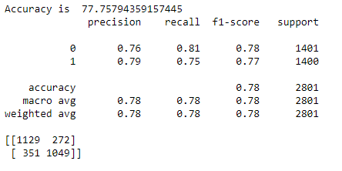

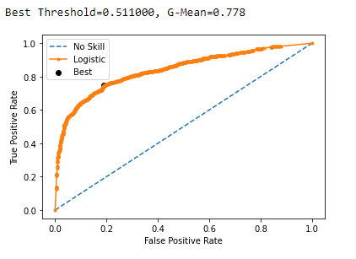

# Results

|  |  |
| --- | --- |
| **Model** | **Accuracy** |
| Decision Tree | 68.10% |
| Naïve Bayes | 64.60% |
| Support Vector Machines | 74.90% |
| **Random Forest** | **77.80%** |

The random forest model yielded the highest test accuracy among all models used.

# Conclusions

1. Is it possible to pre-determine employees who will be promoted?

Yes, multiple modeling techniques were able to reasonably predict the employees that will be promoted.

1. Is it possible to create a model that HR could use to identify great candidates to be promoted?

The HR department of this large multinational corporation can use a random forest model to identify the great candidates who should be promoted.

1. What are the critical drivers of promotion?

As shown in the decision tree model, the average training score, the previous year’s performance rating, and awards won are critical drivers of promotion.

# Appendix A (R code):

# -------------------------------------- Install packages and load libraries --------------------------------------------------------

install.packages("xlsx")

install.packages("arules")

install.packages("arulesViz")

install.packages("ggplot2")

install.packages("ggthemes")

install.packages("dplyr")

install.packages("tidyverse")

install.packages("lattice")

library(xlsx)

library(arules)

library(arulesViz)

library(ggplot2)

library(ggthemes)

library(dplyr)

library(tidyverse)

library(lattice)

library(RColorBrewer)

# -------------------------------------- Read in data --------------------------------------------------------

# Read in data

employee <- read.csv("train.csv")

str(employee)

# -------------------------------------- Data Pre-Processing --------------------------------------------------------

# Convert vars to factors

employee$gender <- factor(employee$gender)

employee$previous_year_rating <- factor(employee$previous_year_rating)

employee$education <- factor(employee$education)

employee$region <- factor(employee$region)

employee$recruitment_channel <- factor(employee$recruitment_channel)

employee$department <- factor(employee$department)

#employee$awards_won. <- factor(employee$awards_won.)

employee$no_of_trainings <- factor(employee$no_of_trainings)

# Check for missing values

is.na(employee)

length(which(is.na(employee)))

employee <- employee[complete.cases(employee),]

employee <- na.omit(employee)

# Promotion var cleaning

employee$is_promoted[employee$is_promoted==1] <- "Promoted"

employee$is_promoted[employee$is_promoted==0] <- "Not Promoted"

employee$is_promoted <- factor(employee$is_promoted)

str(employee$is_promoted)

# Awards won var cleaning

employee$awards_won.[employee$awards_won.==1] <- "Awards Won In Previous Year"

employee$awards_won.[employee$awards_won.==0] <- "No Awards Won in Previous Year"

employee$awards_won. <- factor(employee$awards_won.)

str(employee$awards_won.)

# -------------------------------------- Descriptive Statistics --------------------------------------------------------

# Descriptive statistics: Age

mean(employee$age)

median(employee$age)

freq <- table(employee$age) # frequency distribution

table(employee$age)[which.max(table(employee$age))] # mode

var(employee$age) # variance

sd(employee$age) # standard deviation

max(employee$age) # max

min(employee$age) # min

# -------------------------------------- Visualizations --------------------------------------------------------

# Age Distribution with Density and Mean

ageDist <- ggplot(employee,aes(x=employee$age,fill=employee$gender))+geom_histogram(aes(y=..density..),color="purple",fill="lightblue")+geom_density(alpha=.2, fill="orange")

ageDist <- ageDist + geom_vline(aes(xintercept=mean(employee$age)),color="red", linetype="dashed", size=1)

ageDist + labs(title="Age Histogram",x="Age (years)", y = "Count")

# Age Distribution by Gender

ageDist2 <- ggplot(employee,aes(x=employee$age))+geom_histogram(color="purple",fill="lightblue")+facet_wrap(~employee$gender)

ageDist2 <- ageDist2 + geom_vline(aes(xintercept=mean(employee$age)),color="red", linetype="dashed", size=1)

ageDist2 <- ageDist2 + labs(title="Age Histogram by Gender",x="Age (years)", y = "Count")

ageDist2

# Gender pie

genderTable <- table(employee$gender)

genderTableDF <- as.data.frame(genderTable)

colors <- c("lightpink","lightblue")

genderTableDF$percent <- round(100*genderTableDF$Freq/sum(genderTableDF$Freq), digits = 1)

genderTableDF$label = paste(genderTableDF$Var1," (", genderTableDF$percent,"%)", sep = "")

pie(genderTableDF$Freq, labels = genderTableDF$label, col = colors,main="Gender Percentages")

# Promotion by Gender table

genderPromotion <- table(employee$gender,employee$is_promoted)

genderPromotion

percTableGenderPromotion <- prop.table(genderPromotion,1)

percTableGenderPromotion

# Promotion by Gender ggplot

promotionGenderPerc <- ggplot(employee, aes(x= employee$is_promoted, group=employee$gender)) +

geom_bar(aes(y = ..prop.., fill = factor(..x..)), stat="count") +

geom_text(aes( label = scales::percent(..prop..),

y= ..prop.. ), stat= "count", vjust = -.5) +

labs(y = "Percent", fill="Promotion") +

facet_grid(~employee$gender) +

scale_y_continuous(labels = scales::percent)

promotionGenderPerc + labs(title="Promotion by Gender",x="Promotion", y = "Percent")

# Training Scores Boxplot

promotionScores <- ggplot(employee,aes(x=employee$is_promoted,y=employee$avg_training_score))+geom_boxplot(color="springgreen4",fill="seagreen2")

promotionScores + labs(title="Promotion and Scores Boxplots",x="Promotion", y = "Avg Training Scores")

# Promotion by Dept ggplot

promotionDeptPerc <- ggplot(employee, aes(x= employee$is_promoted, group=employee$department)) +

geom_bar(aes(y = ..prop.., fill = factor(..x..)), stat="count") +

geom_text(aes( label = scales::percent(..prop..),

y= ..prop.. ), stat= "count", vjust = -.5) +

labs(y = "Percent", fill="Promotion") +

facet_wrap(~employee$department,ncol=5) +

scale_y_continuous(labels = scales::percent)

promotionDeptPerc + labs(title="Promotion by Department",x="Promotion", y = "Percent")

# Freq table for dept by promotion

table(employee$department,employee$is_promoted)

# Freq table for avg scores by promotion

table(employee$age,employee$avg_training_score)

# Region scores ggplot

regionScores <- ggplot(employee,aes(x=employee$region,y=employee$avg_training_score))+geom_boxplot(color="blue",fill="white",outlier.colour = "black",outlier.shape = 24,outlier.fill = "red")+facet_wrap(~employee$is_promoted)

regionScores <- regionScores + labs(title="Region and Scores Boxplots",x="Region", y = "Avg Training Scores")+theme(axis.text.x = element_text(angle = 60, hjust = 1))

regionScores + scale_x_discrete(limits = c("region_1", "region_2","region_3","region_4","region_5","region_6","region_7","region_8","region_9","region_10","region_11","region_12","region_13","region_14","region_15","region_16","region_17","region_18","region_19","region_20","region_21","region_22","region_23","region_24","region_25","region_26","region_27","region_28","region_29","region_30","region_31","region_32","region_33","region_34"))

table(employee$length_of_service,employee$awards_won.)

# Age length of service

ageService <- ggplot(employee,aes(x=employee$age,employee$length_of_service,color=employee$is_promoted))+geom_point()#+facet_wrap(~employee$education)

ageService <- ageService + labs(title="Age and Length of Service",x="Age", y = "Length of Service") #+ geom_rangeframe() + theme_tufte()+scale_fill_manual(red)

ageService +theme_hc()+ scale_colour_hc()

# Promotion by Gender table

educationPromotion <- table(employee$education,employee$is_promoted)

educationPromotion

percTableEducationPromotion <- prop.table(educationPromotion,1)

percTableEducationPromotion

#Education Pie

employeeTable <- table(employee$education)

employeeTableDF <- as.data.frame(employeeTable)

colors <- c("lightgreen","lightblue","orange")

employeeTableDF$percent <- round(100*employeeTableDF$Freq/sum(employeeTableDF$Freq), digits = 1)

employeeTableDF$label = paste(employeeTableDF$Var1," (", employeeTableDF$percent,"%)", sep = "")

pie(employeeTableDF$Freq, labels = employeeTableDF$label, col = colors,main="Education Percentages")

# Promotion by Education ggplot

employee$education_f = factor(employee$education, levels=c("Below Secondary","Bachelor's","Master's & above"))

promotionEducationPerc <- ggplot(employee, aes(x= employee$is_promoted, group=employee$education)) +

geom_bar(aes(y = ..prop.., fill = factor(..x..)), stat="count") +

geom_text(aes( label = scales::percent(..prop..),

y= ..prop.. ), stat= "count", vjust = -.5) +

labs(y = "Percent", fill="Promotion") +

facet_grid(~employee$education_f) +

scale_y_continuous(labels = scales::percent)

promotionEducationPerc <- promotionEducationPerc + labs(title="Promotion by Education Level",x="Promotion", y = "Percent")

promotionEducationPerc #+ scale_x_discrete(limits = c("Below Secondary","Bachelor's","Master's & above"))

#Recruitment Pie

employeeRecTable <- table(employee$recruitment_channel)

employeeTableDF <- as.data.frame(employeeRecTable)

colors <- c("purple","yellow","blue")

employeeTableDF$percent <- round(100*employeeTableDF$Freq/sum(employeeTableDF$Freq), digits = 1)

employeeTableDF$label = paste(employeeTableDF$Var1," (", employeeTableDF$percent,"%)", sep = "")

pie(employeeTableDF$Freq, labels = employeeTableDF$label, col = colors,main="Recruitment Channel Percentages")

# Promotion by Recruitment ggplot

employee$recruitment_f = factor(employee$recruitment_channel, levels=c("referred","sourcing","other"))

promotionRecruitmentPerc <- ggplot(employee, aes(x= employee$is_promoted, group=employee$recruitment_channel)) +

geom_bar(aes(y = ..prop.., fill = factor(..x..)), stat="count") +

geom_text(aes( label = scales::percent(..prop..),

y= ..prop.. ), stat= "count", vjust = -.5) +

labs(y = "Percent", fill="Promotion") +

facet_grid(~employee$recruitment_f) +

scale_y_continuous(labels = scales::percent)

promotionRecruitmentPerc + labs(title="Promotion by Recruitment Channel",x="Promotion", y = "Percent")

# Age length of service

trainingsRating <- ggplot(employee,aes(x=employee$age,y=employee$length_of_service))+geom_point(aes(color = employee$awards_won.))#+facet_wrap(~employee$education)

trainingsRating <- trainingsRating + labs(title="Age and No of Trainings",x="Age", y = "No of Trainings") #+ geom_rangeframe() + theme_tufte()+scale_fill_manual(red)

trainingsRating +theme_hc()+ scale_colour_hc()

# Promotion by awards ggplot

#employee$awards_f = factor(employee$awards_won., levels=c('0','1'))

promotionAwardsPerc <- ggplot(employee, aes(x= employee$is_promoted,group=employee$awards_won.)) +

geom_bar(aes(y = ..prop.., fill = factor(..x..)), stat="count") +

geom_text(aes( label = scales::percent(..prop..),

y= ..prop.. ), stat= "count", vjust = -.5) +

labs(y = "Percent", fill="Promotion") +

facet_grid(~employee$awards_won.) +

scale_y_continuous(labels = scales::percent)

promotionAwardsPerc + labs(title="Promotion by Awards Won in Previous Year",x="Promotion", y = "Percent")

# Promotion by trainings ggplot

employee$trainings_f = factor(employee$no_of_trainings, levels=c('0','1'))

promotionTrainingsPerc <- ggplot(employee, aes(x= employee$is_promoted,group=employee$no_of_trainings)) +

geom_bar(aes(y = ..prop.., fill = factor(..x..)), stat="count") +

geom_text(aes( label = scales::percent(..prop..),

y= ..prop.. ), stat= "count", vjust = -.5) +

labs(y = "Percent", fill="Promotion") +

facet_wrap(~employee$no_of_trainings,ncol=5) +

scale_y_continuous(labels = scales::percent)

promotionTrainingsPerc + labs(title="Promotion by No of Trainings",x="Promotion", y = "Percent")

# Dept Trainings Plot

deptTrainingsScores <- ggplot(employee,aes(x=employee$age,y=employee$no_of_trainings,color=employee$is_promoted))+geom_point()+facet_wrap(~employee$department)

deptTrainingsScores <- deptTrainingsScores + labs(title="Age and No of Trainings",x="Age", y = "No of Trainings")+theme(axis.text.x = element_text(angle = 60, hjust = 1))

deptTrainingsScores

# Promotion by Regions ggplot

employee$regions_f = factor(employee$regions, levels=c('0','1'))

promotionRegionPerc <- ggplot(employee, aes(x= employee$is_promoted,group=employee$region)) +

geom_bar(aes(y = ..prop.., fill = factor(..x..)), stat="count") +

geom_text(aes( label = scales::percent(..prop..),

y= ..prop.. ), stat= "count", vjust = -.5) +

labs(y = "Percent", fill="Promotion") +

facet_wrap(~employee$region,ncol=13) +

scale_y_continuous(labels = scales::percent)

promotionRegionPerc + labs(title="Promotion by No of Trainings",x="Promotion", y = "Percent")

ggplot(data=employee,aes(x=employee$age,y=employee$previous_year_rating,fill=employee$is_promoted))

ggplot(employee, aes(employee$previous_year_rating, fill = employee$is_promoted)) + geom_histogram(stat="count",binwidth = 500)+ labs(title="Promotion by No of Trainings",x="Promotion", y = "Percent")#+ scale_y_continuous(labels = scales::percent)

ratingTable <- table(employee$is_promoted,employee$previous_year_rating)

ratingTab <- prop.table(ratingTable,1)

ratingTab

ratingTab <- as.data.frame(ratingTab)

ggplot(ratingTab, aes(x=Var2,y=Freq,fill=Var1))+geom_col()

# Promotion by Previous Rating ggplot

promotionRatingPerc <- ggplot(employee, aes(x= employee$is_promoted, group=employee$previous_year_rating)) +

geom_bar(aes(y = ..prop.., fill = factor(..x..)), stat="count") +

geom_text(aes( label = scales::percent(..prop..),

y= ..prop.. ), stat= "count", vjust = -.5) +

labs(y = "Percent", fill="Promotion") +

facet_grid(~employee$previous_year_rating) +

scale_y_continuous(labels = scales::percent)

promotionRatingPerc + labs(title="Promotion by Previous Year Rating",x="Promotion", y = "Percent")

# Promotion by Region ggplot

promotionRegionPerc <- ggplot(employee, aes(x= employee$region, group=employee$is_promoted)) +

geom_bar(aes(y = ..prop.., fill = factor(..x..)), stat="count") +

geom_text(aes( label = scales::percent(..prop..),

y= ..prop.. ), stat= "count", vjust = -.5) +

labs(y = "Percent", fill="Promotion") +

facet_wrap(~employee$is_promoted,ncol=1) +

scale_y_continuous(labels = scales::percent)

promotionRegionPerc <- promotionRegionPerc + labs(title="Promotion by Previous Year Rating",x="Promotion", y = "Percent")+theme(axis.text.x = element_text(angle = 60, hjust = 1))

promotionRegionPerc + scale_x_discrete(limits = c("region_1", "region_2","region_3","region_4","region_5","region_6","region_7","region_8","region_9","region_10","region_11","region_12","region_13","region_14","region_15","region_16","region_17","region_18","region_19","region_20","region_21","region_22","region_23","region_24","region_25","region_26","region_27","region_28","region_29","region_30","region_31","region_32","region_33","region_34"))

regionDeptPromotion <- ggplot(employee,aes(x=employee$region,fill=employee$department))+geom_bar(stat="count")+facet_wrap(~employee$is_promoted)+theme(axis.text.x = element_text(angle = 60, hjust = 1))+ scale_x_discrete(limits = c("region_1", "region_2","region_3","region_4","region_5","region_6","region_7","region_8","region_9","region_10","region_11","region_12","region_13","region_14","region_15","region_16","region_17","region_18","region_19","region_20","region_21","region_22","region_23","region_24","region_25","region_26","region_27","region_28","region_29","region_30","region_31","region_32","region_33","region_34"))

regionDeptPromotion+ labs(title="Promotions by Region and Dept",x="Region", y = "Count")

#Gender EDA

gender_table <- table(train_df$gender, train_df$is_promoted)

colnames(gender_table)<- c("Not Promoted", "Promoted")

rownames(gender_table)<- c("Female", "Male")

barplot(gender_table, legend=TRUE, main="Promotions by Gender")

#Department EDA

department_table <- table(train_df$department)

pie(department_table, main="Department Breakdown of Employees")

#Age EDA

par(mfrow = c(2,1))

age_table <- table(train_df$age)

plot(age_table, main="Age Distribution of All Employees", xlab="Employee Age", ylab="Frequency")

age_table_promoted <- table(train_df$age[train_df$is_promoted==1])

plot(age_table, main="Age Distribution of Promoted Employees", xlab="Employee Age", ylab="Frequency")

#Correlation Matrix EDA

par(mar=c(5,5,10,5))

cor(train_df$no_of_trainings, train_df$is_promoted)

numeric_vars_only <- train_df[c(-1, -2, -3, -4, -5, -6, -9)]

####install.packages("corrplot")

library(corrplot)

corrplot(cor(numeric_vars_only), method="number", type="lower", col=colorRampPalette("blue"))

# -------------------------------------- Discretization --------------------------------------------------------

# Discretize length of service into custom bins

employee$length_of_service <- cut(employee$length_of_service, breaks = c(0,5,10,15,20,25,30,35,40),labels=c("1-5","6-10","11-15","16-20","21-25","26-30", "31-35","36-40"))

head(employee$length_of_service)

table(employee$length_of_service)

# Discretize avg training score

employee$avg_training_score <-cut(employee$avg_training_score,breaks=c(30,40,50,60,70,80,90,100),labels=c("<=40","41-50", "51-60","61-70","71-80","81-90","91-100"))

head(employee$avg_training_score)

table(employee$avg_training_score)

# Discretize age

employee$age <- cut(employee$age, breaks = c(10,20,30,40,50,60,70),labels=c("11-20","21-30","31-40","41-50","51-60","61-70"))

head(employee$age)

table(employee$age)

# Remove employee id row

employee <- employee[,c(-1)]

# -------------------------------------- Apriori --------------------------------------------------------

# Create rule set

ruleset <- apriori(employee, parameter = list(support=0.015,confidence = 0.75))

summary(ruleset)

plot(ruleset[1:30])

# Show the top 5 rules, rounding with 2 digits

options(digits=2)

inspect(ruleset[1:30])

# Sort rules so that we can view the most relevant rules first. For example, sort rules with "confidence":

rules<-sort(ruleset, by="confidence", decreasing=TRUE)

options(digits=2)

inspect(rules[1:10])

# Create short list of best rules

goodrules1 <- rules[quality(rules)$lift > 2]

inspect(goodrules1[1:10])

plot(goodrules1)

# Set rhs to promotion

rules<-apriori(data=employee, parameter=list(supp=0.005,conf = 0.20), appearance = list(default="lhs",rhs="is_promoted=Promoted"))

rules<-sort(rules, decreasing=TRUE,by='confidence')

options(digits=2)

inspect(rules[1:10])

plot(rules)

# Create short list of best sup rules

goodsuprules1 <- rules[quality(rules)$supp > 0.005]

inspect(goodsuprules1[1:10])

plot(goodrules1)

# Set rhs to promotion

rules3<-apriori(data=employee, parameter=list(supp=0.007,conf = 0.20), appearance = list(default="lhs",rhs="is_promoted=Promoted"))

rules3<-sort(rules3, decreasing=TRUE,by='support')

options(digits=2)

inspect(rules3[1:10])

#plot(rules)

# Set rhs to promotion

rules4<-apriori(data=employee, parameter=list(supp=0.005,conf = 0.22), appearance = list(default="lhs",rhs="is_promoted=Promoted"))

rules4<-sort(rules4, decreasing=TRUE,by='confidence')

options(digits=2)

inspect(rules4[1:10])

# -------------------------------------- Data Prep for Modeling --------------------------------------------------------

remove_empty_edu <- train_df[train_df$education == c("Bachelor's")]

library(dplyr)

remove_empty_edu <- filter(train_df, education == "Bachelor's" | education == "Master's & above" | education == "Below Secondary")

unique(remove_empty_edu["education"])

str(remove_empty_edu)

head(remove_empty_edu)

remove_empty_edu$education[which(remove_empty_edu$education=="Below Secondary")] <- "1"

remove_empty_edu$education[which(remove_empty_edu$education=="Bachelor's")] <- "2"

remove_empty_edu$education[which(remove_empty_edu$education=="Master's & above")] <- "3"

remove_empty_edu$education <- as.numeric(remove_empty_edu$education)

remove_empty_edu$gender[which(remove_empty_edu$gender=="f")] <- "1"

remove_empty_edu$gender[which(remove_empty_edu$gender=="m")] <- "0"

unique(remove_empty_edu["department"])

remove_empty_edu <- filter(train_df, education == "Bachelor's" | education == "Master's & above" | education == "Below Secondary")

remove_employee_id <- remove_empty_edu[,-1]

remove_age <- remove_employee_id[,-7]

remove_age$previous_year_rating <- as.integer(remove_age$previous_year_rating)

remove_age$education[which(remove_age$education=="Below Secondary")] <- "1"

remove_age$education[which(remove_age$education=="Bachelor's")] <- "2"

remove_age$education[which(remove_age$education=="Master's & above")] <- "3"

remove_age$education <- as.integer(remove_age$education)

remove_age$gender[which(remove_age$gender=="f")] <- "1"

remove_age$gender[which(remove_age$gender=="m")] <- "0"

remove_age$gender <- as.integer(remove_age$gender)

remove_age$recruitment_channel[which(remove_age$recruitment_channel=="sourcing")] <- "1"

remove_age$recruitment_channel[which(remove_age$recruitment_channel=="other")] <- "2"

remove_age$recruitment_channel[which(remove_age$recruitment_channel=="referred")] <- "3"

remove_age$recruitment_channel <- as.integer(remove_age$recruitment_channel)

remove_dept <- remove_age[,-1]

remove_region <- remove_dept[,-1]

###install.packages("ROSE")

library(ROSE)

#Down-sampling

table(remove_region$is_promoted)

data_balanced <- ovun.sample(is_promoted ~ ., data = remove_region, method = "under", N = 9000, seed = 1)$data

table(data_balanced$is_promoted)

splitter <- sort(sample(nrow(data_balanced), nrow(data_balanced)*.7))

train_70 <- data_balanced[splitter,]

test_30 <- data_balanced[-splitter,]

table(test_30$is_promoted)

# -------------------------------------- Modeling --------------------------------------------------------

#Naive Bayes

model_nb <- naiveBayes(as.factor(is_promoted)~., data=train_70, na.action=na.pass)

prediction_nb <- predict(model_nb, test_30[,-9], na.action=na.pass)

table(`Actual` = test_30$is.promoted, `Predicted` = prediction_nb)

nb_accuracy <- (1-(sum(test_30$is_promoted != prediction_nb)/nrow(test_30))) *100

nrow(test_30)

nrow(prediction_nb)

confusionMatrix(prediction_nb, as.factor(test_30$is_promoted))

plot(prediction_nb, main="Naive Bayes Predicted", col=c("gray", "lightblue"))

plot(as.factor(test_30$is_promoted), main="Actual", xlab="Promotion Status", col=c("gray", "lightblue"))

#DecisionTree

library(rpart)

dt_model <- rpart(is_promoted ~ .,method = "class", data = train_70)

summary(dt_model)

predict_dt <- predict(dt_model, newdata = test_30[,-9], type = "class")

confusionMatrix(predict_dt, as.factor(test_30$is_promoted))

dt_model_1 <- rpart(is_promoted ~., data=train_70, method="class", control = list(maxdepth = 2))

dt_model_2 <- rpart(is_promoted ~., data=train_70, method="class", control = list(xval=20))

predict_dt <- predict(dt_model, newdata = test_30[,-9], type = "class")

predict_dt1 <- predict(dt_model_1, newdata = test_30[,-9], type = "class")

predict_dt2 <- predict(dt_model_2, newdata = test_30[,-9], type = "class")

confusionMatrix(predict_dt, as.factor(test_30$is_promoted))

confusionMatrix(predict_dt1, as.factor(test_30$is_promoted))

confusionMatrix(predict_dt2, as.factor(test_30$is_promoted))

library(rattle)

library(RColorBrewer)

fancyRpartPlot(dt_model, main="Decision Tree Default")

fancyRpartPlot(dt_model_1, main="Decision Tree Pruned")

fancyRpartPlot(dt_model_2, main="Decision Tree Increased Cross Validations")

# Appendix B (Python code):

import pandas as pd

import numpy as np

from datetime import datetime

import warnings

warnings.filterwarnings('ignore')

df = pd.read_csv("train.csv",delimiter=',')

#identify null value amounts

total = df.isnull().sum().sort_values(ascending = False)

percent = (df.isnull().sum()/df.isnull().count()).sort_values(ascending=False)

missing_data = pd.concat([total,percent], axis = 1, keys= ['Total', 'Percent'])

print(missing_data)

#preprocessing the variables

df = df.drop(['employee_id','region','recruitment_channel'],axis= 1)

from sklearn.preprocessing import LabelEncoder

from sklearn.preprocessing import OneHotEncoder

# creating instance of labelencoder

labelencoder = LabelEncoder()

df['education'] = df['education'].astype(str)

df['education'] = labelencoder.fit_transform(df['education'])

df['department'] = df['department'].astype(str)

df['department'] = labelencoder.fit_transform(df['department'])

df['gender'] = pd.get_dummies(df['gender'])

#replacing null values with median

df = df.replace(np.nan,df.median())

#independent and dependent variables

X = df.drop('is_promoted',axis=1)

y = df['is_promoted']

from sklearn.ensemble import RandomForestClassifier

from sklearn.svm import SVC

#Import svm model

from sklearn import svm

from sklearn.model_selection import train_test_split

from sklearn.metrics import accuracy_score

X_train, X_test, y_train, y_test = train_test_split(X,y,test_size=0.3,random_state = 1)

#SVM poly

#Create a svm Classifier

SvM = svm.SVC(kernel='poly') # Poly Kernel

#Train the model using the training sets

SvM.fit(X_train, y_train)

predictions = SvM.predict(X_test)

predictions

from sklearn.model_selection import cross_val_score

cross_val_score(SvM, X, y, cv=3)

from sklearn.metrics import classification_report, confusion_matrix

from sklearn.metrics import accuracy_score

SvM.fit(X_train,y_train)

predictions = SvM.predict(X_test)

predictions

print("Accuracy is ", accuracy_score(y_test,predictions)*100)

print(classification_report(y_test,predictions))

print(confusion_matrix(y_test,predictions))

#Random Forest

from sklearn.ensemble import RandomForestClassifier

# Create a based model

rf = RandomForestClassifier()

#Train the model using the training sets

rf.fit(X_train, y_train)

from sklearn.model_selection import cross_val_score

cross_val_score(rf, X, y, cv=3)

rf.fit(X_train,y_train)

predictions = rf.predict(X_test)

predictions

print("Accuracy is ", accuracy_score(y_test,predictions)*100)

print(classification_report(y_test,predictions))

print(confusion_matrix(y_test,predictions))

#Near Miss sampling with SVM and Random Forest

from imblearn.under_sampling import NearMiss

nm = NearMiss()

x_nm,y_nm = nm.fit_resample(X,y)

X_train, X_test, y_train, y_test = train_test_split(x_nm,y_nm,test_size=0.3,random_state = 1)

rf.fit(X_train,y_train)

predictions = rf.predict(X_test)

predictions

print("Accuracy is ", accuracy_score(y_test,predictions)*100)

print(classification_report(y_test,predictions))

print(confusion_matrix(y_test,predictions))

# roc curve for logistic regression model with optimal threshold

from numpy import sqrt

from numpy import argmax

from sklearn.metrics import roc_curve

from matplotlib import pyplot

# predict probabilities

yhat = rf.predict_proba(X_test)

# keep probabilities for the positive outcome only

yhat = yhat[:, 1]

# calculate roc curves

fpr, tpr, thresholds = roc_curve(y_test, yhat)

# calculate the g-mean for each threshold

gmeans = sqrt(tpr * (1-fpr))

# locate the index of the largest g-mean

ix = argmax(gmeans)

print('Best Threshold=%f, G-Mean=%.3f' % (thresholds[ix], gmeans[ix]))

# plot the roc curve for the model

pyplot.plot([0,1], [0,1], linestyle='--', label='No Skill')

pyplot.plot(fpr, tpr, marker='.', label='Logistic')

pyplot.scatter(fpr[ix], tpr[ix], marker='o', color='black', label='Best')

# axis labels

pyplot.xlabel('False Positive Rate')

pyplot.ylabel('True Positive Rate')

pyplot.legend()

# show the plot

pyplot.show()

#Poly

SvM.fit(X_train,y_train)

predictions = SvM.predict(X_test)

predictions

print("Accuracy is ", accuracy_score(y_test,predictions)*100)

print(classification_report(y_test,predictions))

print(confusion_matrix(y_test,predictions))

#Linear

#Create a svm Classifier

SvM = svm.SVC(kernel='linear')

SvM.fit(X_train,y_train)

predictions = SvM.predict(X_test)

predictions

print("Accuracy is ", accuracy_score(y_test,predictions)*100)

print(classification_report(y_test,predictions))

print(confusion_matrix(y_test,predictions))

#rbf kernel

#Create a svm Classifier

SvM = svm.SVC(kernel='rbf')

SvM.fit(X_train,y_train)

predictions = SvM.predict(X_test)

predictions

print("Accuracy is ", accuracy_score(y_test,predictions)*100)

print(classification_report(y_test,predictions))

print(confusion_matrix(y_test,predictions))